***(Whether these are AR cards or models that require swipe motion) depends on the technology available.)***

**P**

|  |  |
| --- | --- |
| **AR card/Swipe model 1 - Plate movements** (Unit 1.3 p. 34) |  |
| Fig. 1 | 1. Scan the target image    * Shows Fig. 1    * Model sticks to the target image    * Buttons: Divergent, Convergent, Transform, ⭯ (reset; goes back to Fig. 1)    * Can always view model from the top and from each side by moving the target image or the device    * Labels and buttons are all bilingual |
| Fig. 2 | 1. Tap Divergent    * Shows Fig. 2 (arrows signaling users to pull the plates apart) |
| Fig. 3 | 1. Pull the plates apart from each other (swipe action)    * Shows animation of plates moving apart and new land forming in the middle    * Animation ends on Fig. 3 |
| Fig. 4 | 1. Tap Convergent    * Shows Fig. 4 (arrows signaling users to move the plates towards each other) |
| Fig. 5 | 1. Move the plates together (swipe action)    * Shows animation of plates moving towards each other and one plate subducting under the other    * Animation ends on Fig. 5 |
| Fig. 6 | 1. Tap Transform    * Shows Fig. 6 (arrows signaling users to move the p lates past each other) |
| Fig. 7 | 1. Sliding the plates past each other (swipe action)    * Shows animation of plates sliding past each other    * Animation ends on Fig. 7 |
|  |  |
| Remarks:   * All labels and buttons are subject to change. |  |

* All figures should be coloured and have real life-like textures:

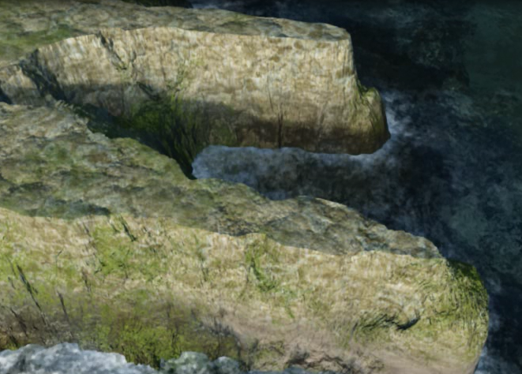 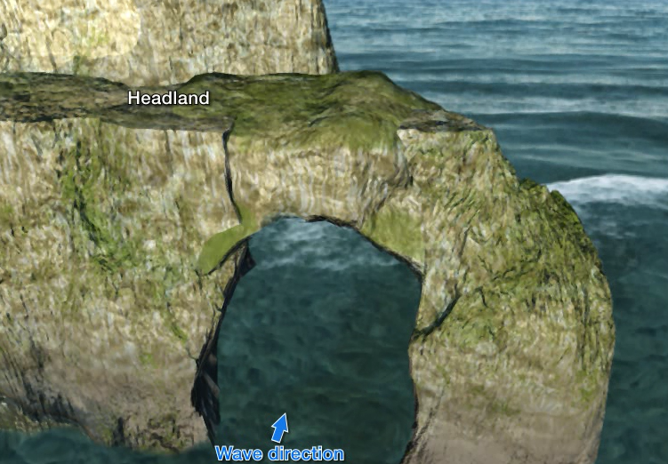

|  |  |
| --- | --- |
| **AR card/model 2 – Volcanic island arc** (Unit 1.4 p. 64)  **P** |  |
| Fig. 1 | 1. Scan the target image    * Shows Fig. 1 (arrow signaling users to tap the hot spot)    * 2-D model sticks to the target image    * Button: ⭯ (reset; goes back to Fig. 1)    * Labels and buttons are all bilingual |
| Fig. 2 | 1. Tap the hot spot    * Shows animation of hot spot enlarging and magma rising to form a volcanic island    * Animation ends on Fig. 2 (without arrow)    * Animation stops then show arrow signaling users to pull the plate to the left |
| Fig. 3 | 1. Drag the plate to the left (swipe action)    * Volcano and the plate (but not the asthenosphere and the hot spot) move to the left and stops at a certain point (Fig. 3) |
| Fig. 4 | * + Then show animation of magma rising to form another volcanic island   + Animation ends on Fig. 4   + Then show arrow signaling users to pull the plate to the left |
| Fig. 5 | 1. Drag the plate to the left (swipe action)    * Volcanoes and the plate (but not the asthenosphere and the hot spot) move to the left and stops at another point    * Then show animation of magma rising to form the third volcanic island    * Animation ends at Fig. 5 |
|  |  |
| Remarks:   * All labels and buttons are subject to change. |  |

* All figures should be coloured and have real life-like textures:

 

* ***If swipe action is not feasible, produce an animation instead.***

|  |  |  |
| --- | --- | --- |
| **AR card/Swipe model 3 - Equinoxes and solstices** (Unit 9.1 p.10) | |  |
| Fig. 1 | 1. Scan the target image    * Shows Fig. 1 (arrow signaling users to drag the earth along the orbit)    * Button: ⭯ (reset; goes back to Fig. 1)    * Can always view model from the top and from each side by moving the target image or the device    * Labels and buttons are all bilingual    * Earth is tilted and constantly rotating | |
| Fig. 2 | 1. Drag earth along the orbit    * Position of sunlight on the earth changes    * Earth keeps rotating | |
| Fig. 3 | 1. Drag earth into one of the four dotted circles    * Shows labels about the corresponding equinox or solstice (Fig. 3 is winter solstice)    * Earth keeps rotating | |
| Fig. 4 Spring equinox | Fig. 5 Summer solstice | |
| Fig. 6 Autumnal equinox |  | |

|  |  |
| --- | --- |
| Remarks:   * All labels and buttons are subject to change. |  |

* All figures should be coloured and have real life-like textures:

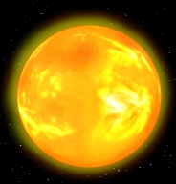 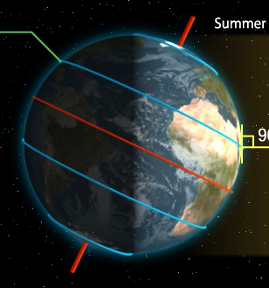

|  |  |
| --- | --- |
| **Swipe model 4 - Coriolis effect** (Unit 9.3 p.36) |  |
| Fig. 1 | 1. Scan the target image    * Shows Fig. 1      + 3-D earth      + Arrows signaling users to rotate the earth, tilt the earth downwards, and tilt upwards      + Can swipe    * Button: ⭯ reset (goes back to Fig. 1)    * When the earth is stationery, all arrows are straight    * Labels and buttons are all bilingual |
| Fig. 2 | 1. Swipe to rotate the earth (only allows rotation from west towards east)    * Arrows deflect (shown in Fig. 2)    * When the user stops swipe, rotation slowly stops and arrows become straight again    * Can swipe upwards and downwards while rotating |
| Fig. 3 | 1. Swipe downwards to see the north pole    * Shows animation of tilting of the top of the earth towards the user    * Only allow rotating anti-clockwise    * Arrows deflect (shown in Fig. 3)    * When the user stops swipe, rotation slowly stops and arrows become straight again |
| Fig. 4 | 1. Swipe upwards to see the south pole    * Shows animation of tilting of the bottom of the earth towards the user    * Only allow rotating clockwise    * Arrows deflect (shown in Fig. 4)    * When the user stops swipe, rotation slowly stops and arrows become straight again |
|  |  |
| Remarks:   * All labels and buttons are subject to change. |  |

* All figures should be coloured and have real life-like textures:

